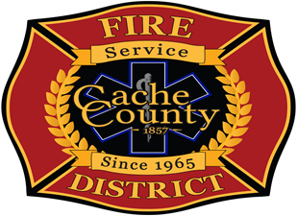 | Cache County Fire District Appeals Board

Cache County Fire District Appeals Board
Agenda
Wednesday, July 2, 2025 @ 11 AM
1020 East 600 North Hyrum, Utah 84319

1. Items of Discussion
- Return Development LLC and Saddle Ridge LLC’s appeal.

